# **Company Name:** LoxkMe

**Company Profile**

* Our company is determined to secure and maintain client information to facilitate both clients and hospitals.

**Group Member:** Waris Damkham, Pattanan Korkiattrakool, Thanakij Pinyoboon

# **Website Title & Meta Description**

* **Website Title:  
  ○** LoxkMe | IT solutions | Cybersecurity Consultancy | Cybersecurity Company |
* **Meta Description:  
  ○** LoxkMe-Cybersecurity Consultancy-IT consultant-IT solutions-Advice

# **Pre-writing**

## Audience

* Hospitals and companies need a consultant or administrator that covers the security and transmission of their data.
* Clients who need experts in foundation and database maintenance.

## Expected purpose of the website

* We expect audiences who visit our website to have the complete information they need. Moreover, we want them to be able to use the information they get from visiting our website, to solve the problems they were facing. In addition, we are committed to ensuring that our website visitors are able to access and perceive who we are, in order to build trust when they choose to use our services.

# **Organizational**

* **Company Name:** LoxkMe
* **About us:** Confidence and origin of our company
* **Company description & Service**: Why does it have to be LoxkMe?
* **Values & Vision:** Our objectives and goals
* **Contact information:** Our official contact information to contact our company

# **Consultant Personal Biography:** Our company CEOs, Co-founders, and developers background.

# **Pre-writing Company description**

Positive Business-Related Adjectives: (adjective)

## Company Description & service

LoxkMe was located in Sathorn, Bangkok by three co-founders: Waris, Pattanan, and Thanakij. LoxkMe employs about a thousand people who are full of efficiency, and potential to help clients maintain their data. LoxkMe is a company where clients can rest assured that their data is kept safe and secure. On behalf of LoxkMe, we are committed to securing and maintaining client information in every case, to facilitate our customers with competence, efficiency, and responsibility of all our employees. There are many cybersecurity resources on our company website, we also create and deliver knowledge to help clients and organizations by providing total solutions and including expert advice. Our core service is to maintain a database system for clients and organizations who require system administration from the beginning to the end of the system maintenance. Another interesting service of LoxkMe is cooperation with hospitals. Certainly, keeping patient information is a significant matter for the hospital, thus they require LoxkMe to handle that aspect. At the time the patient receives blood test results, their data is stored in the database, and use a network system forward data by having to go through the approval from the hospital before the result can be transmitted along with LoxkMe security's system. You may find furthermore information or would like to inquire about our services via LoxkMe's website, and email address.

## About us

* LoxkMe company was established on the first of May 2026 and was located in Sathorn, Bangkok. LoxkMe company was founded from the idea of three co-founders who wanted to create and deliver knowledge to help organizations meet real-world, evolving business and information technology needs. Our ultimate objective is to provide total solutions, including expert advice, tools, training, and assessment, for any IT governance, risk, and compliance requirements of any type. We believe in the security and stability of an organization's information which that two will lead to the foundation of corporate strength.

## Values & Vision

* LoxkMe company, we believe in best practices are great tools to help business executives of both public and private sectors to properly manage their information technology strategies to achieve strategic goals, protect and secure their intellectual properties, ensure market value with a meet related corporate governance, and regulatory compliance objectives. Our main objective is to prevent the risk of information and security strategies that enable a business to compete and sustainable growth in the global information economy.

## Contact information

* Website: [www.LoxkMe.com](http://www.loxkme.com)
* Email: [LoxkMe.group@hotmail.com](mailto:LoxkMe.group@hotmail.com)
* Tel: 097-782-1156
* Sathorn, Bangkok

# **Consultant Personal Biography** (Meta description)

* **Waris Damkham**

Waris Damkham is the CEO of LoxkMe, a company whose founder is enjoying his work experience by developing and designing a website. He expects his organization to enhance business IT services for customers who want to prevent the risk to their security of data. He got his degree in Computer Network from Mahidol University's Faculty of Information and Communication Technology. He has expertise in developing websites using CSS, HTML, and JavaScript. He started to be obsessed with designing websites when he was in his sophomore year, and he also used his website design skills to be an intern at Taiwan's A.I. internship. He has experience working in the website development field for five years. He aims to develop his company to become more prosperous in the future.

* **Pattanan Korkiattrakool**

Pattanan Korkiattrakool is a data analyst and co-founder of LoxkMe company. She is fascinated with the analytics surrounding information in her life. Her primary responsibility is to analyze the company's historical data, so the company can use this analyzed information to improve its business services further. She graduated from the Faculty of Information and Communication Technology, Mahidol University. When she was in her sophomore year, she did a database project which gathered information from Apple Music, and it was the starting point for her interest in the field. She has excellent skills in data analysis, SQL, dashboard creation, and using various tools which she can work as a data analyst for up to 3 years without pressure and bitterness, she is also full of happiness at work. Currently, she is a senior data analyst at the LoxkMe company, and she will keep producing quality work in the future.

* **Thanakij Pinyoboon**

Thanakij Pinyoboon is a co-founder and chief software engineer of LoxkMe company. His responsibility focused on determining all technology requirements of the company and preparing appropriate growth and development plans. He graduated from the Faculty of Information Communication Technology, Mahidol University in 2024 with a GPAX of 3.75. He worked as a front-end developer during his internship at True Corporation in his fourth-year university. He got experience in full-stack development when he worked at Wongnai for three years with his full potential. From his experience, he is a specialist expert in UI and UX for designing websites. His hobby is playing card games and video games, it encourages him to plan and think strategically. It also improves his ability to make connections also use logical thinking also helps him foster problem-solving skills, creativity, and communication skills. Currently, he is a chief software engineer at the LoxkMe company to develop software solutions by studying information needs, conferring with users, and determining operational feasibility by evaluating analysis, problem definition, requirements, solution development, and proposed solutions. His contact detail is LinkedIn: Thanakij Pinyoboon or E-mail: [thanakij.pin@LoxkMe.com](mailto:thanakij.pin@LoxkMe.com).

# 

# 

# 

# 

# 

# **SEO Keywords:**

|  |  |
| --- | --- |
| **Keywords** | **FAQ /LTP(Long-tail-phrases)** |

|  |  |  |
| --- | --- | --- |
| Maintaining data | Data protection | Sathorn area data protection company |
| Cybersecurity Consultancy | IT solutions | Maintaining data IT consultant |
| IT consultant | Advice | Bangkok Cyber Security Consultancy |
| Data transmission | Network security | High-quality data protection consultant |
| Database | Data Security | Data security, Cloud data, advice, and consultant |

# **Call to action**

* If you are interested in knowing information about Cybersecurity, and databases, feel free to visit our website. Join the millions who are fighting to protect our data.

# 

# 

# 

# 

# **Website design Layout**

* An example of a website layout when displayed in the desktop.

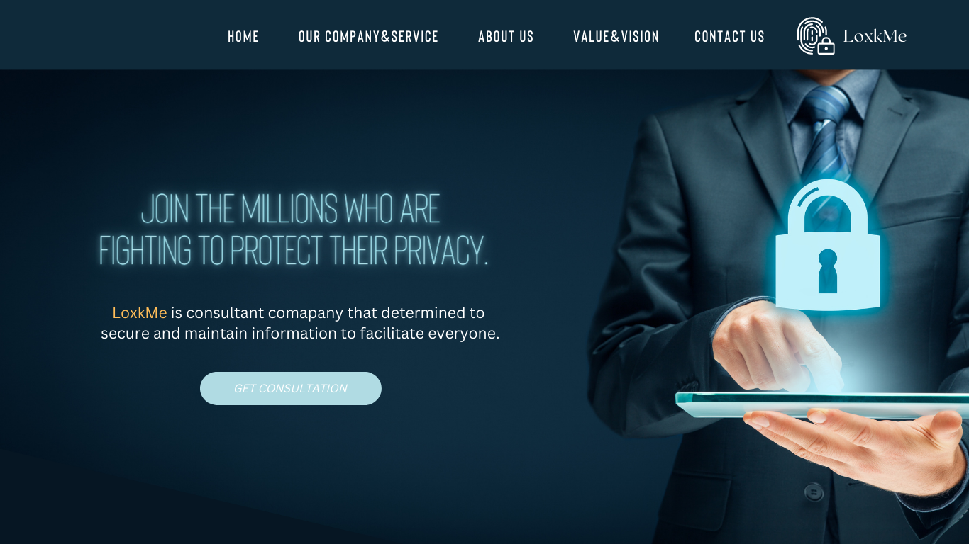

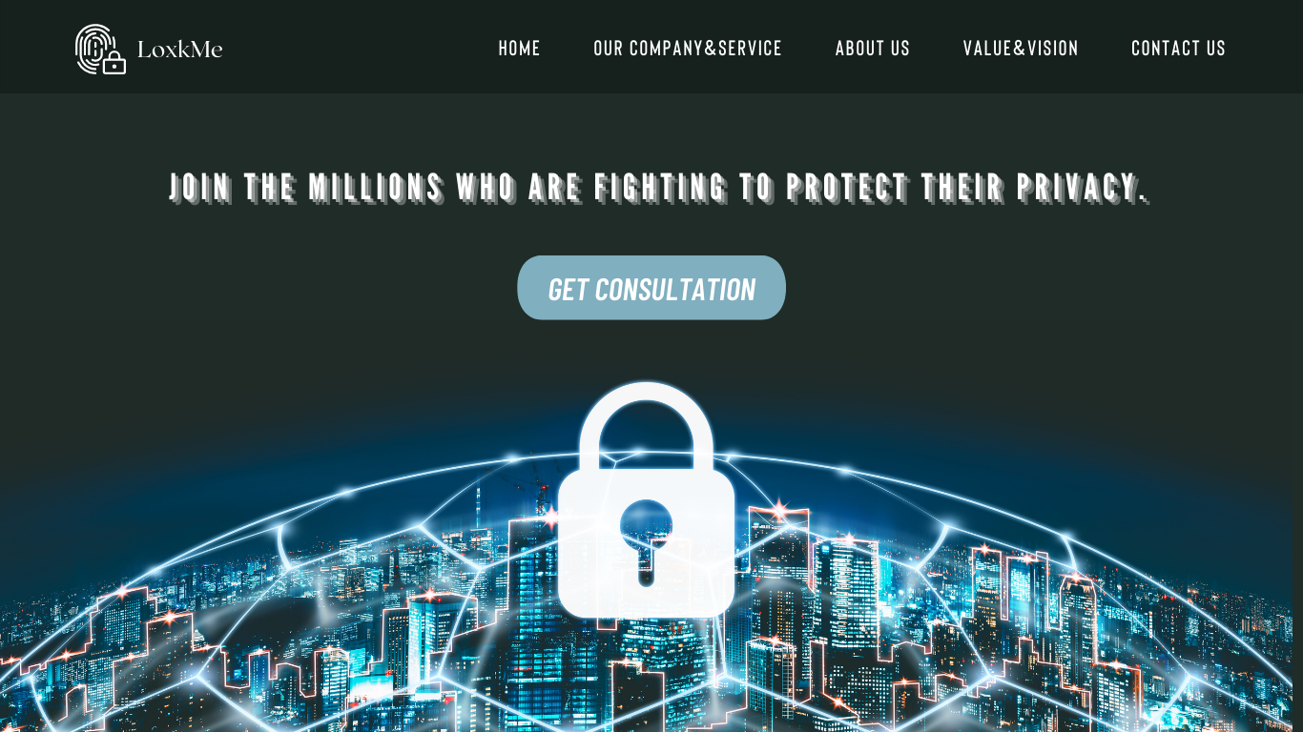

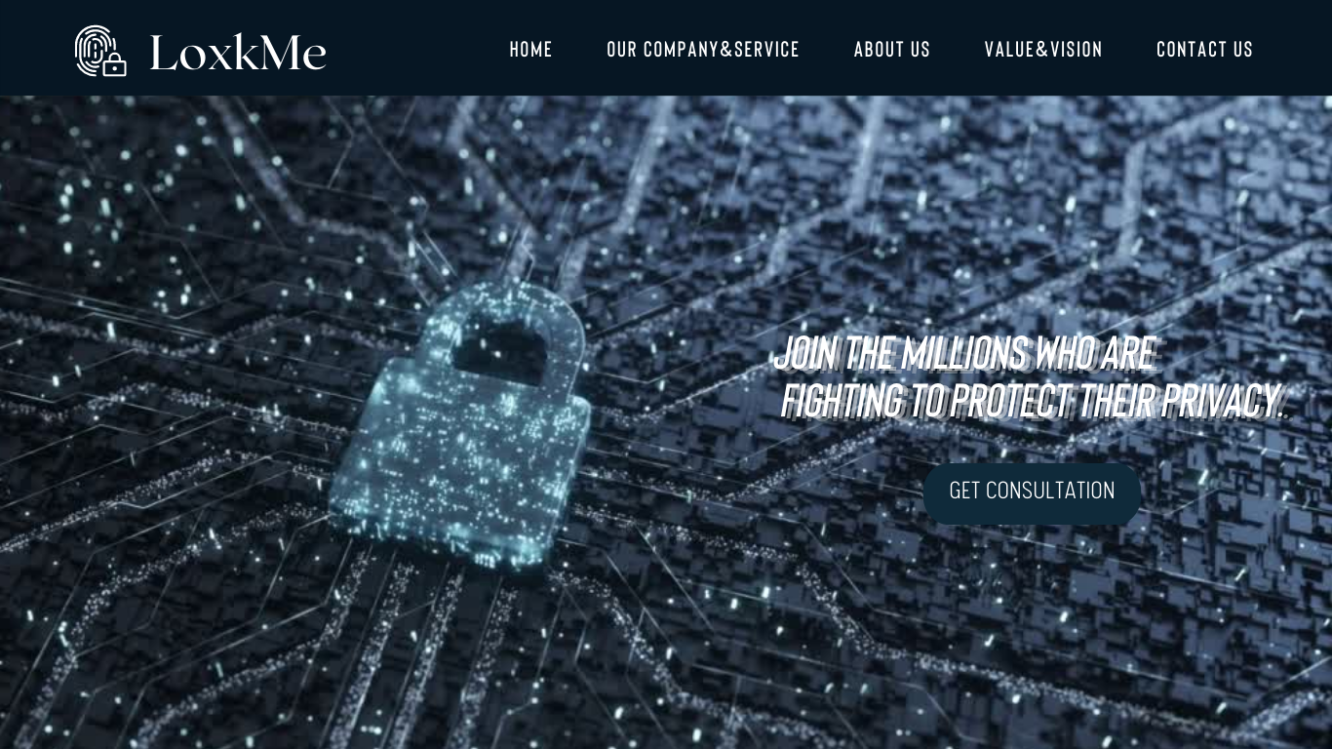

# **Report checking**

* MS Word readability statistics report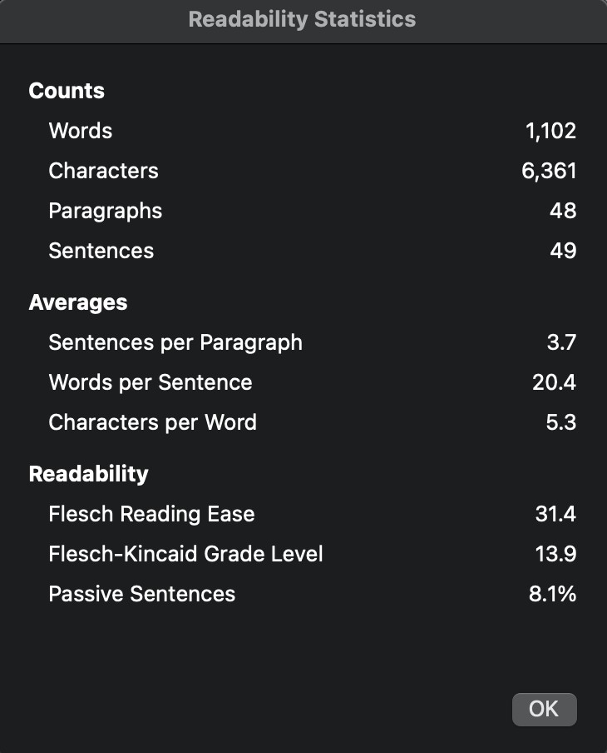
* Grammarly Report